In the age when dark was thick and settlements rare, when a church bell was music and messenger of fortunes and misfortunes, when roads were bad and outlaws prowl would at the crossroads, in that age of knight tournaments and barefoot pilgrimages, lived king Krešimir. He ruled the Croatian sea and surrounding land with the help of district prefects and courtiers, dedicated to Rome and careful with the Byzantium Empire. He spent his days hunting bores, does, pirates and even Venetian vessels.

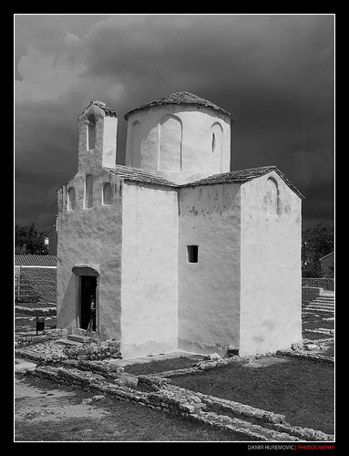
He had a daughter named Manduša. As a child she got over a bad fever, and she was brought back from the edge of death by the touch of God. Her sick body was brought to life in church Sv. Spas by a ray of light. That place is magical because it was built as a calendar and the day that night and day are equal, sun rays fall exactly in the middle of the church through a tiny window. It is supposed that at the time Manduša gained her special power that was not procurable for any other mortal.

As Manduša grew up, she had a companion named Dobromir. Dobromir was noble orphan that king took under his protection. They spent their youth reading, hunting and exploring the coast side together. It was evident that their friendship evolved into a deep connection that made even the queen raises her eyebrows in a worried way, and a king to smile, even though he was concerned what would happen when the time comes when Manduša will have to marry a king.
One day Manduša and Dobromir sailed to a little island. Just as they found some mollusks to eat, the sun became dark and a great storm came. They ran to the safety of a cave and waited for a storm to abate. The next day when the sun woke them up, they hade realized that their boat was missing. At this point they were very thirsty, their tongues hade hardened and they became week. Manduša said exhaustedly: “If there is water on this island I will find it!” Dobromir followed her and started digging in a place that didn’t seem too promising. After some time he found water that helped them survive until the kings solders found them. Dobromir was assured by Manduša’s special abilities.
One year later a Hungarian emissary came to propose Manduša’s hand. the King, although sad, firmly accepted. He told Manduša and Dobromir that they knew this day would come. He promised her hand to Hungarian king Emerik. Although Dobromir was a noble, he isn’t a king and could not marry Manduša. Manduša cried for three days and Dobromir collected her tears into a bottle.
When the day of the princess’s departure came, the king appointed Dobromir as a head of her escort. Not only because he was the bravest and most loyal knight, but because he wanted to give them few more days to say goodbye.
The voyage was extremely long because the princess was obstructing it with different excuses. She didn’t want to part from her beloved one. Finally they hade reached land and started to travel on horses. Emerik’s messengers kept bringing the news of king’s impatience. A Few days before the arrival of the messenger whom brought news of the king Emerik’s tragic hunting accident. He didn’t survive. Everyone was shocked. Manduša was, at the same time shocked with the news and glad because now there is a chance she could marry Dobromir. The procession headed back through the inland. That summer the drought was so tough that it turned rivers into muddy roads. After a while everyone was exhausted, they ran out of wine and water. They knew they wouldn’t last much longer. Dobromir turned his eyes on Manduša and told her: “If someone could help us that would be you.” She answered:” Once, in a dream, an angel came to me and told me I mustn’t use my powers unless there is great need.” He smiled and told: “I think this is a situation of a great need.” Manduša took a dousing rod and after a long walk, on the bottom of two hills, her rod trembled. She excitedly exclaimed: “Zagrebite (Croatian word for scratch, scrape)!” And indeed there was a wellspring with clear and cold water.
That night Dobromir told Manduša: “We should build a town here and name it Zagreb, after the word you exclaimed when you came to this place, and the well in its center should be named after you Manduša - Manduševac.”
That is how Zagreb got its name, and the well that reminds us of Manduša, and how she is still in the heart of Zagreb, right on the Jelačić square.
