Blogging Rubric 2010 – 2011
7th & 8th Grade

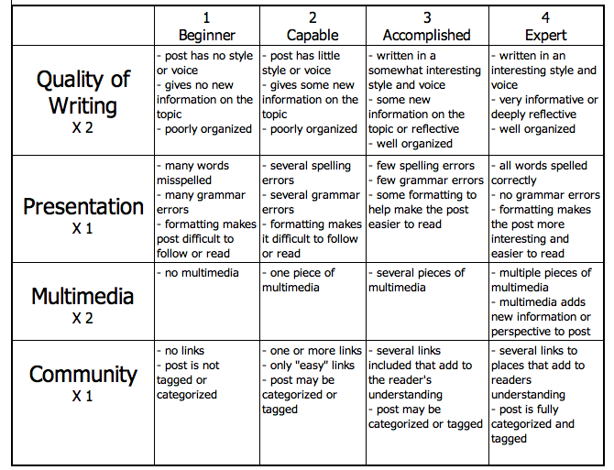
http://www.evenfromhere.org/wp-content/uploads/2010/02/blogging-rubric1.png

Quality of Writing – have you included everything we covered and explained something a bit more, have you written in a manner that is exciting to read, have you used appropriate and necessary Science vocabulary?

Presentation - spelling, grammar, punctuation, is it in a readable format, are you pictures captioned and related?

Multimedia – do you have multiple & related pictures, does it give new information that is related & interesting, do your links work, are they hyperlinked?

Community - have you linked to Moodle, have you linked elsewhere, are your links related & provide new information, is your post labeled correctly?

Blog Posted on Time Yes No
Comments:

Grade for Scribe Post = /25

Comment posts: 2 posts to own class, 2 posts to other class

Due Date | Comment Posted To | Score  (2 pts.) | Comments about Post
Friday, February 4th

Thursday, February 17th

Friday, March 11th

Friday March 25th

All on time Yes No
Extras Yes No

Remember – Please include compliments, criticisms and science coverage! These are other people’s words, be sure to be polite with your comment and not too harsh! Honesty is the best policy, but be careful you are not mean!

Comment Posts = /10

Reflection post –
Yes No Homework grade = /5

Total Grade for Blogging = /40

