Guide to using Audacity

Important Note: You will be using Audacity to create an audio media file in an MP3 format. Once you have created this file you will move it into the shared seventh grade folder where you will see a folder for Wellness Radio Commercials.

\\Server\Student Public Folder\Gr. 7\Wellness Radio Commercials

A Tour of the Audacity Window:

Shown below is a sample of the open Audacity window:
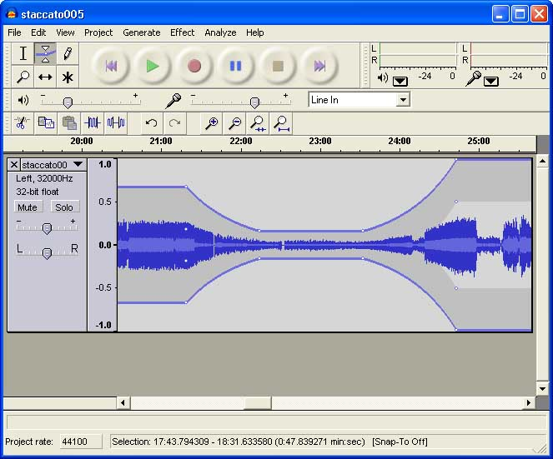

To use Audacity double click the icon on your desktop. The window will look like the one above.

Open the program you want to record from or go to the website with the sound you want to record; when you are ready to record click back into audacity and press the red record button at the top of the screen then start playing the file on the web or in the other program.

When you are finished recording press the stop button, then stop the sound from the other program if it has not stopped itself. Now you have a recording of the other program in Audacity, press the play button to hear what you recorded.

To save your project click the file menu and rather than clicking save, select Export as MP3. Exporting as an MP3 file will allow you to save the project to be played in other programs such as Windows Media Player or iTunes.
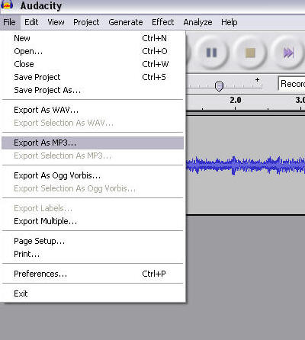

If you are having problems recording try the following:
Make sure the recording level is loud enough by sliding the microphone tab to the right. It is located just under the record and pause buttons.
Make sure your selected input is the correct one. The drop menu next to the recording level will display what is currently selected; by clicking on the menu you can see the other options. Depending on your individual computer these settings will be different, but if you see one called Record Master this will be the easiest to use.

