Blogging Rubric 2010 – 2011
7th – 4th Quarter
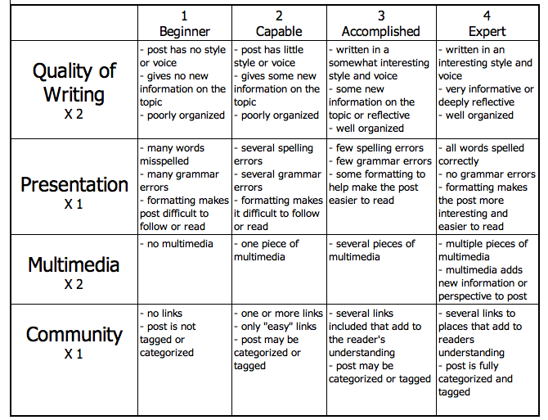
http://www.evenfromhere.org/wp-content/uploads/2010/02/blogging-rubric1.png
Quality of Writing – have you included everything we covered, have explained something a bit more scientifically, have you written in a manner that is exciting to read, have you used appropriate and necessary Science vocabulary, do you have a real life relationship?

Presentation - spelling, grammar, punctuation, have you used colors, is it in a readable format?

Multimedia – do you have multiple & related pictures, are your pictures captioned, do they give new information that is related & interesting, do your links work, are they hyperlinked?

Community - have you linked to Moodle, have you linked elsewhere, are your links related & provide new information, is your post labeled correctly, your title includes the date of the class?

Blog Posted on Time Yes No
Comments:

Grade for Scribe Post = /25

Comment posts: 2 posts to own class, 2 posts to other class

Due Date | Comment Posted To | Score  (2 pts.) | Comments about Post
Friday, April 15th
(Must be an 8th grade comment)
Friday, May 6th

Friday, May 20th

Tuesday, May 31st

All on time Yes No
Extras Yes No

Remember – Please include compliments, criticisms and science coverage! These are other people’s words, be sure to be polite with your comment and not too harsh! Honesty is the best policy, but be careful you are not mean!

Comment Posts = /10

Reflection post – Due Tuesday, May 31st!

Yes No Homework grade = /5

Total Grade for Blogging = /40

