Blogging Rubric 2010 – 2011
8th Grade – 4th Quarter
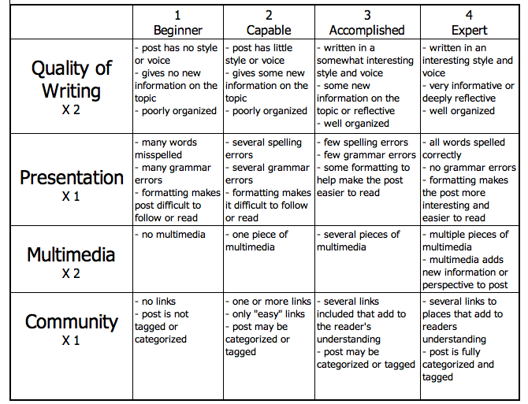
http://www.evenfromhere.org/wp-content/uploads/2010/02/blogging-rubric1.png

Quality of Writing – have you included everything you covered in your presentation, have you written in a manner that is exciting to read, have you used appropriate and necessary Science vocabulary?

Presentation - spelling, grammar, punctuation, have you used colors, is it in a readable format?

Multimedia – do you have multiple & related pictures, are your pictures captioned, do your links work, are they hyperlinked, does it give new information that is related & interesting to your presentation?

Community - have you linked to Moodle, have you linked to your notes, have you linked elsewhere, are your links related & provide new information, is your post labeled correctly, does your title include the date of the class?

Blog Posted on Time Yes No
Comments:

Grade for Scribe Post = /25

Comment posts: 2 posts to own class, 2 posts to other class

Due Date | Comment Posted To | Score  (2 pts.) | Comments about Post
Friday, April 15th
(Must be an 8th grade comment)
Friday, May 6th

Friday, May 20th

Tuesday, May 31st

All on time Yes No
Extras Yes No

Remember – Please include compliments, criticisms and science coverage! These are other people’s words, be sure to be polite with your comment and not too harsh! Honesty is the best policy, but be careful you are not mean!

Comment Posts = /10

Reflection post – Due Tuesday, May 31st!

Yes No Homework grade = /5

Total Grade for Blogging = /40

