The Earth
By Reza
Origin of Name
- came from English/German name which means ground
Size
- diameter at the equator - 12,756.32 kilometers
- mass - 5.97 x 10^24 kilograms
- density - 5.51 grams per cubic centimetre
Revolution
- revolves around the Sun
- takes approximately 365.25 days to revolve around the Sun
Rotation
- tipped on its axis approximately 23.5 degrees from vertical
- rotates once in 24 hours
- approximately at a rate of 1609.344 kilometres per hour
Climate
- consists of four seasons
- spring, summer, autumn, and fall
- least warm temperature recorded temperature - 89.4 degrees Celsius
- Recorded at Vostok Station Antarctica
- warmest temperature on Earth - 56.7 degrees Celsius
Chemical Composition
- 34.6% iron
- 29.5% oxygen
- 15.2% silicon
- 12.7% magnesium
- 2.4% nickel
- 1.9% sulfur
- 0.05% titanium
Relation to the Sun
- third planet from the sun
- minimum distance - 146 million kilometers
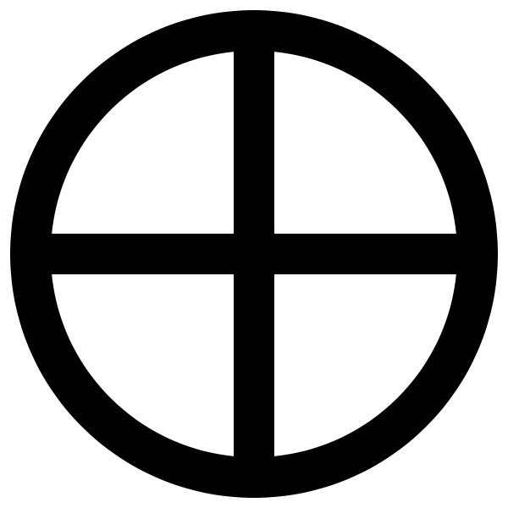
- maximum distance - 152 million km
- exactly one AU
- AU stands for Astronomical Unit
Discovery
- Discovered approximately 38,000 by the first humans
- they just looked down
The Moon
- brightest object in the sky besides the sun
- orbits around Earth once a month
The Symbol --------------------------------------------------------
- end of each line represents one of the four elements
- they are wind, earth, water, and fire

