CHEM TEST QUESTIONS
- Who was the first person in history to propese the concept of atom?
- Why didn't this concept catch on?
- How did the ancient Greeks view the World?
- What is phlogistone and what was its role in the history of chemistry?
- Compare the proton, neutron and electron.
- What is periodicity?
- What is atomic number?
- What is an ion?
- What is an isotope?
- What is the Aufbau principle?
- What is an orbital? What are possible shapes of orbitals? What orbitals can you name?
- What is Hund's rule?
- Interpret the notation 1s²2s²2p¹.

- What is common to the elements in the same row?
- What is common to the elements in the same column?
- What is the relative atomic mass number?

- What is Carbon-14 dating? Explain how it is done.
- How many atoms/mollecules are in one mole of a substance?
- How many liters does one mole of substance occupy in gaseous form at standard temperature and pressure (0 ºC , 1 bar)?
- Fill the electron shells for the following elements:
a) ⁹ F   | b) ¹⁶ S

- Which one of these element's doesn't belong and why?

a) | 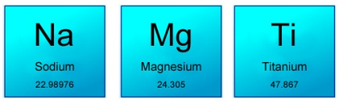 | b) | 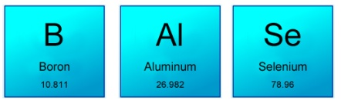
c) | 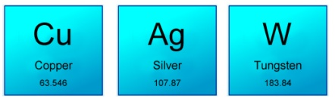 | d) | 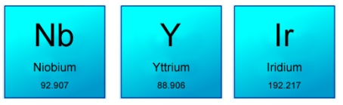
e) | 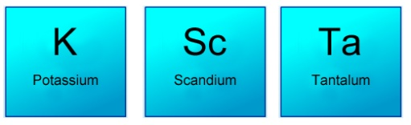 | f) | 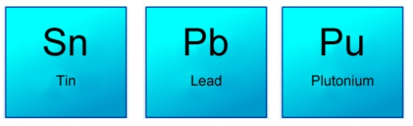

- Make aluminum – sulphate.

- Make Calcium – nitrate.

BIO TEST QUESTIONS
- Darwin collected many organisms from these volcanic islands off the coast of South America.
- What is the title and publication date of Darwin's most significant publication?
- Darwin acquired his degree in which field?
- Who was Darwin's greatest oponnent and a believer in gradualism?
- Who propesed the theory of gradualism and at what time frame?
- Who developed a nerly identical theory of natural selection around the same time as Darwin?
- Who created the binomial classification system for organisms that is still in use today?
- What was the name of the theory proposed by Georges Cuvier in which periodic natural disasters wiped out large groups of organisms?
- Give Darwin's age at each of the following points in his life: a) going to college b) setting sail on the Beagle c) publishing his book
- Who believed in the view of nature that assumed organisms were fixed and not evolving and could be laced on a ladder of increasing complexity? (hint: think Ancient Greece)
- Approximately how old is Earth, according to geologic dating?
- Approximately when did life on Earth first appear in the geologic record?
- What are protobionts?
- Name one of the energy sources thought to drive the anabolic reactions of the first molecules of life.
- What does anabolic and catabolic mean?
- What is spontaneous generation and what is biogenesis?
- What is a gene?
- What are alleles of a gene?
- What is a phenotype?
- If you unwound a DNA molucule, how long would it be?
- What are nucleic acids?
- Who were James Watson, Francis Crick and Maurice Wilkins?
- What is the name of the DNA duplication process? What is the main enzyme that participates in it?
- What is a "codon"?
- What holds one strand against the other in the double helix?
- Where was the discovery of DNA first announced?
- What is mitosis and what is meiosis?
- How many stages does mitosis have?
- How many stages does meiosis have?
- Name all the stages of mitosis.
- What are centrosomes?
- What are microtubules?
- How many chromosomes does a healthy human cell have?
- What is the haploid and what is the diploid number of chromosomes for a human?
- What are histones?
- Write the appropriate DNA strand to match the following: A T C G G A T G .
- How many different amino-acids make up all the proteins in a human body?
- Sort the early stages of development from earliest to latest: emryoblast, zygote, morula, hapoid cells, organ development.
- What makes embrionic stem cell so special?

- Name three diseases caused by bacteria.
- List three beneficial bacteria.
- Approximately what percentage of the human body are bacteria?
- What is the difference between eukaryotes and prokaryotes?
- Sketch and label the main parts of a bacterium.
- When was penicillin invented and by whom?
- Why do we say that viruses are between the living and non-living world?
- Sketch and label the main parts of a virus.
- Describe the life cycle of a virus.
- What is cell lysis?
- What is a retrovirus? Why are they especially sinister?
- What are bacteriophages?
- List three diseases caused by viruses.
- What is diffusion? Elaborate.
- What is osmosis? Elaborate.
- What does hypotonic and hypertonic mean?
- Where is osmosis important in the human body?

- Write everything you know about red blood cells. (at least 3 pieces information required)

- Sketch a neuron and list its main parts.
- Why is the sodium-potassium pump important to the functioning of our nervous system?
- How does the sodium-potassium pump work?
- What is the main fuel molecule used in the human body, also used in the sodium-potassium pump?

