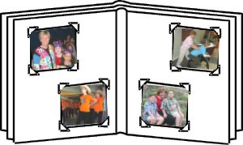

Français 5e - Mme Kenderic
Amis et compagnie A1

Unité 2: Ma famille et moi

By the end of Unité 2, you will be able to …

- introduce friends and family members
- tell your birthday, the birthday of others
- use numbers to 39 when speaking and writing
- use the months of the year
- identify pets / some animals
- tell what you have and what you do not have
- use colours
- use both “avoir” and “etre” in the correct situations
- produce and present a family album with accompanying text

To be able to communicate and accomplish all of the above tasks,
you will learn how to use or you will continue to use …
- the verbs avoir and être
- avoir + expressions with this verb (ex. Nous avons toujours raison.)
- verbs in the present tense + an infinitive (ex. Il déteste jouer au foot. Elle n’aime pas lire.)
- definite articles le/la/l’/les (the)
- possessive adjectives
- the negative ne/n’ … pas and pas + de/d’
- vocabulary about family members, pets/animals, numbers, months, colours

You will also …
- learn how to identify the silent –e when reading and speaking

You will have formative assessments (reading, writing, speaking, and listening) throughout the unit as well as a final Unit 2 summative test.

