Français 5
Unité 2 – La Famille
Le 21 novembre, 2014
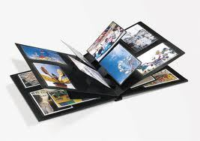

Mon album de photos

Dear Students,

Our unit of study is the family. One of the projects I would like to do with you is “Mon album de photos”, a photo album. Each student will create her/his album which includes photos and a short description of the person/pet. In order to begin, each student needs to have some family pictures.

With this in mind, I would like that you send to me either via an attachment in WORD or via Google Drive your chosen photos. These should be sent to me by Monday, December 1st at the latest. My e-mail address is bernadette.kenderic@aisz.hr

I will take care of printing your photos.

You will need a total of 6 pictures.
-1 of yourself
-1 of parents (either mom and dad together or separate pictures)
-1 of sisters/brothers (could be in a family picture or individual)
OPTIONAL-1 of pet(s) (can be with members of the family; if more than 1 pet, all pets can be in one photo)

In addition, you will need to choose 3 persons from the list below and send pictures (they can be in a group picture):
-a grandmother
- a grandfather
-an aunt
-an uncle
-a male cousin
-a female cousin
-a great-grandmother / a great-grandfather, a great aunt, a great uncle

Should you have any questions, please do not hesitate to contact me at bernadette.kenderic@aisz.hr

