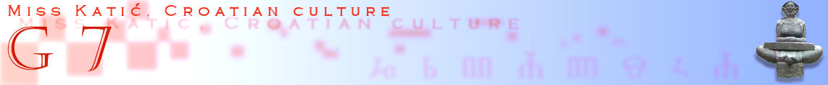

- What is a Nature Park?

- Name Nature Parks in Croatia:

1.
2.
3.
4.
5.
6.
7.
8.
9.
10.
11.

- What is a National Park?

- Name National parks in Croatia:

1.
2.
3.
4.
5.
6.
7.
8.

- What is a strict reserve?

- Name Strict reserves in Croatia:

1.
2.

- What is UNESCO?

- What is World Heritage List?

- Name Properties inscribed on the Worlds Heritage List in Croatia

1.
2.
3.
4.
5.
6.
7.

- Take a good look at the map. Try to find all the Nature Park and National Parks listed above!
