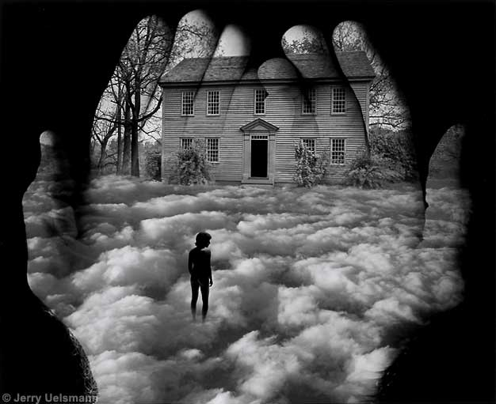

Surreal/Symbolic Self Portrait
Putting together what we have learned

Digital is a media used by artists to express themselves. You don’t have to be an expert in everything that you do. Sometimes the challenges of a new media help us to grow as an artist just like drawing with the other side of our hand brings out different aspects of our self. Photoshop can be used by all ability levels. Be creative, fearless and above all thoughtful in your process.

Media: photoshop
Technique: Digital collage
Artist Models: Maggie Taylor
Jerry Uelsmann
Magritte or Salvidor Dali

Objectives:
- To create a surreal self portrait using digital media using adobe photoshop
- Incorporate at least three symbols that represent your life/ cultural backgrounds.

Process:
Background:
Define surrealism and surreal self portrait: look for inspiring facts about the artists
Maggie Taylor: http://www.maggietaylor.com/ .
Jerry Uelsmann http://www.uelsmann.net/
Magritte: http://www.mcs.csuhayward.edu/~malek/Magrit.html

Planning:
What will go into your digital composition ie what type of background will you have, what
symbols/ images will you use? What are some of your own personal myths? Think about the influence of family, culture and school. Do some visual thinking make a list of possibilities. Take a photo of yourself .

Studio:
You know a lot about photoshop now. Don’t be afraid to experiment! Set Image Size to International paper A4 and 200 dpi. Help one another to recall how to use this powerful image manipulation program. When complete flatten the layers, save as a JPEG file . Upload to BearNet.

