Arrival of the Croats

There, where strong young river flows to the infinite plain and northern seas lies a citadel surrounded by high stakes and with a deep ditch. There lived a brother and a sister- Hrvat i Tuga. They had four brothers and a sister- Buga, who were rarely in the citadel since they where leaders of their tribes.

Land was rich, intersected with numerous forest roads, hedgerows and gardens. There was lots of game in the forests, in the fields ox plowed and rivers were full of fish. By the huts, surrounding a citadel there laid swords and spikes at rest and in the stalls strong horses rested.

Croats called their land White Croatia. Tuga was leading them strongly and wisely and when all failed Tuga, as a Croat, was the one that led people to glory. Tuga was attractive women and as such she had lot wooers including the mighty Savo, the governor of West Slavs who saw her when she was young and never forgot about her. He was responsible for the death of her father when he was trying to conquer a Constantinople and Tuga vowed to remain a virgin because she would loose the power of foretell.
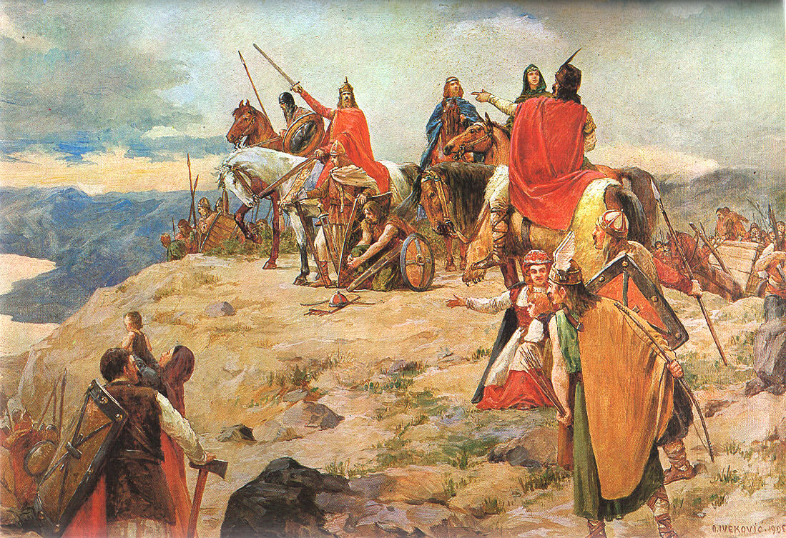
Tuga frequently saw pictures in her mind and yet she did not know were those terrible pictures from the future or past... but she knew that these cold forests were not a home for Croats. Byzantine emperor Heracles knew about history much more but he was not able to see the future. The emperor was in tough position because the East Roman Empire was at a brink of collapse. And he heard about Croats. He thought that they where to be a powerful allies, so he sent an emissary with one hundred horses and a wagon full of valuables, as a gift for negotiation.

When the emissary distributed gifts amongst them he was amazed how these Croats where not following blindly, on a contrary, they where yelling, drinking mead and drawing their swords. the Emissary was afraid for his life, but he needn’t to worry because for Croats having a guest was greatest honor of all.
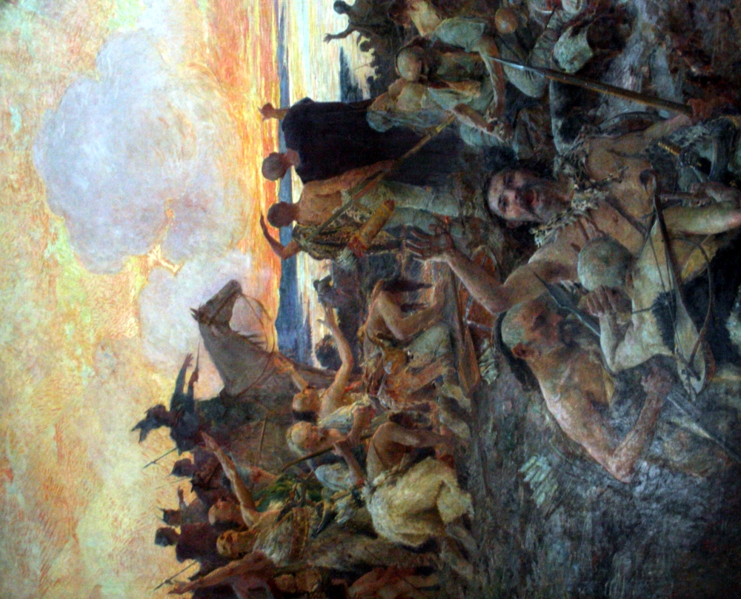
After three nights of counseling there were two main thoughts. One thought that they should reject the offer of Byzantine emperor for alliance even though they would get southern lands of today’s Dalmatia, Primorje and Istria, and the others were for it. Tuga was the one of the last to make up her mind. She stepped on the log and said that southern lands where a message from Gods, and thus persuaded the other half of people.

When the snow melted Croat army started to march towards southern lands... Duke Hrvat led them to the seacoast. Finally Tuga saw the endless sea. She was so mesmerized that she sat looking at the distance for a long time. But soon she snapped out of it and reminded her self that that land will have to be paid for by sweat, blood and tears.

Duke sends his scouts to seek out the main body of Avar army; they reported that there was a significant concentration of the enemy in the Jadro delta, in the ruins of, before that, rich and prosperous town of Salona. When the horses were well rested from lengthily march, the Croats attacked mainly from the left flank thus surprising Avars and pushed them to retreat. Once there, subdued people started to join Croats making Croat army even stronger and fiercer. They pushed Avars to the north all the way to the river Sava, where they found the killer of their fathers and took revenge.

Concurred land Croats named Croatia. They made their borders the river Drava on the North and river Danube on the east. Their old Homeland was now merely in the mist and this new land on the south became, and still is- the one and only homeland of Croats.

Hrvoje Hitrec

