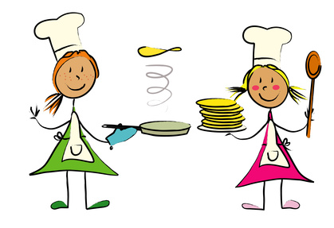
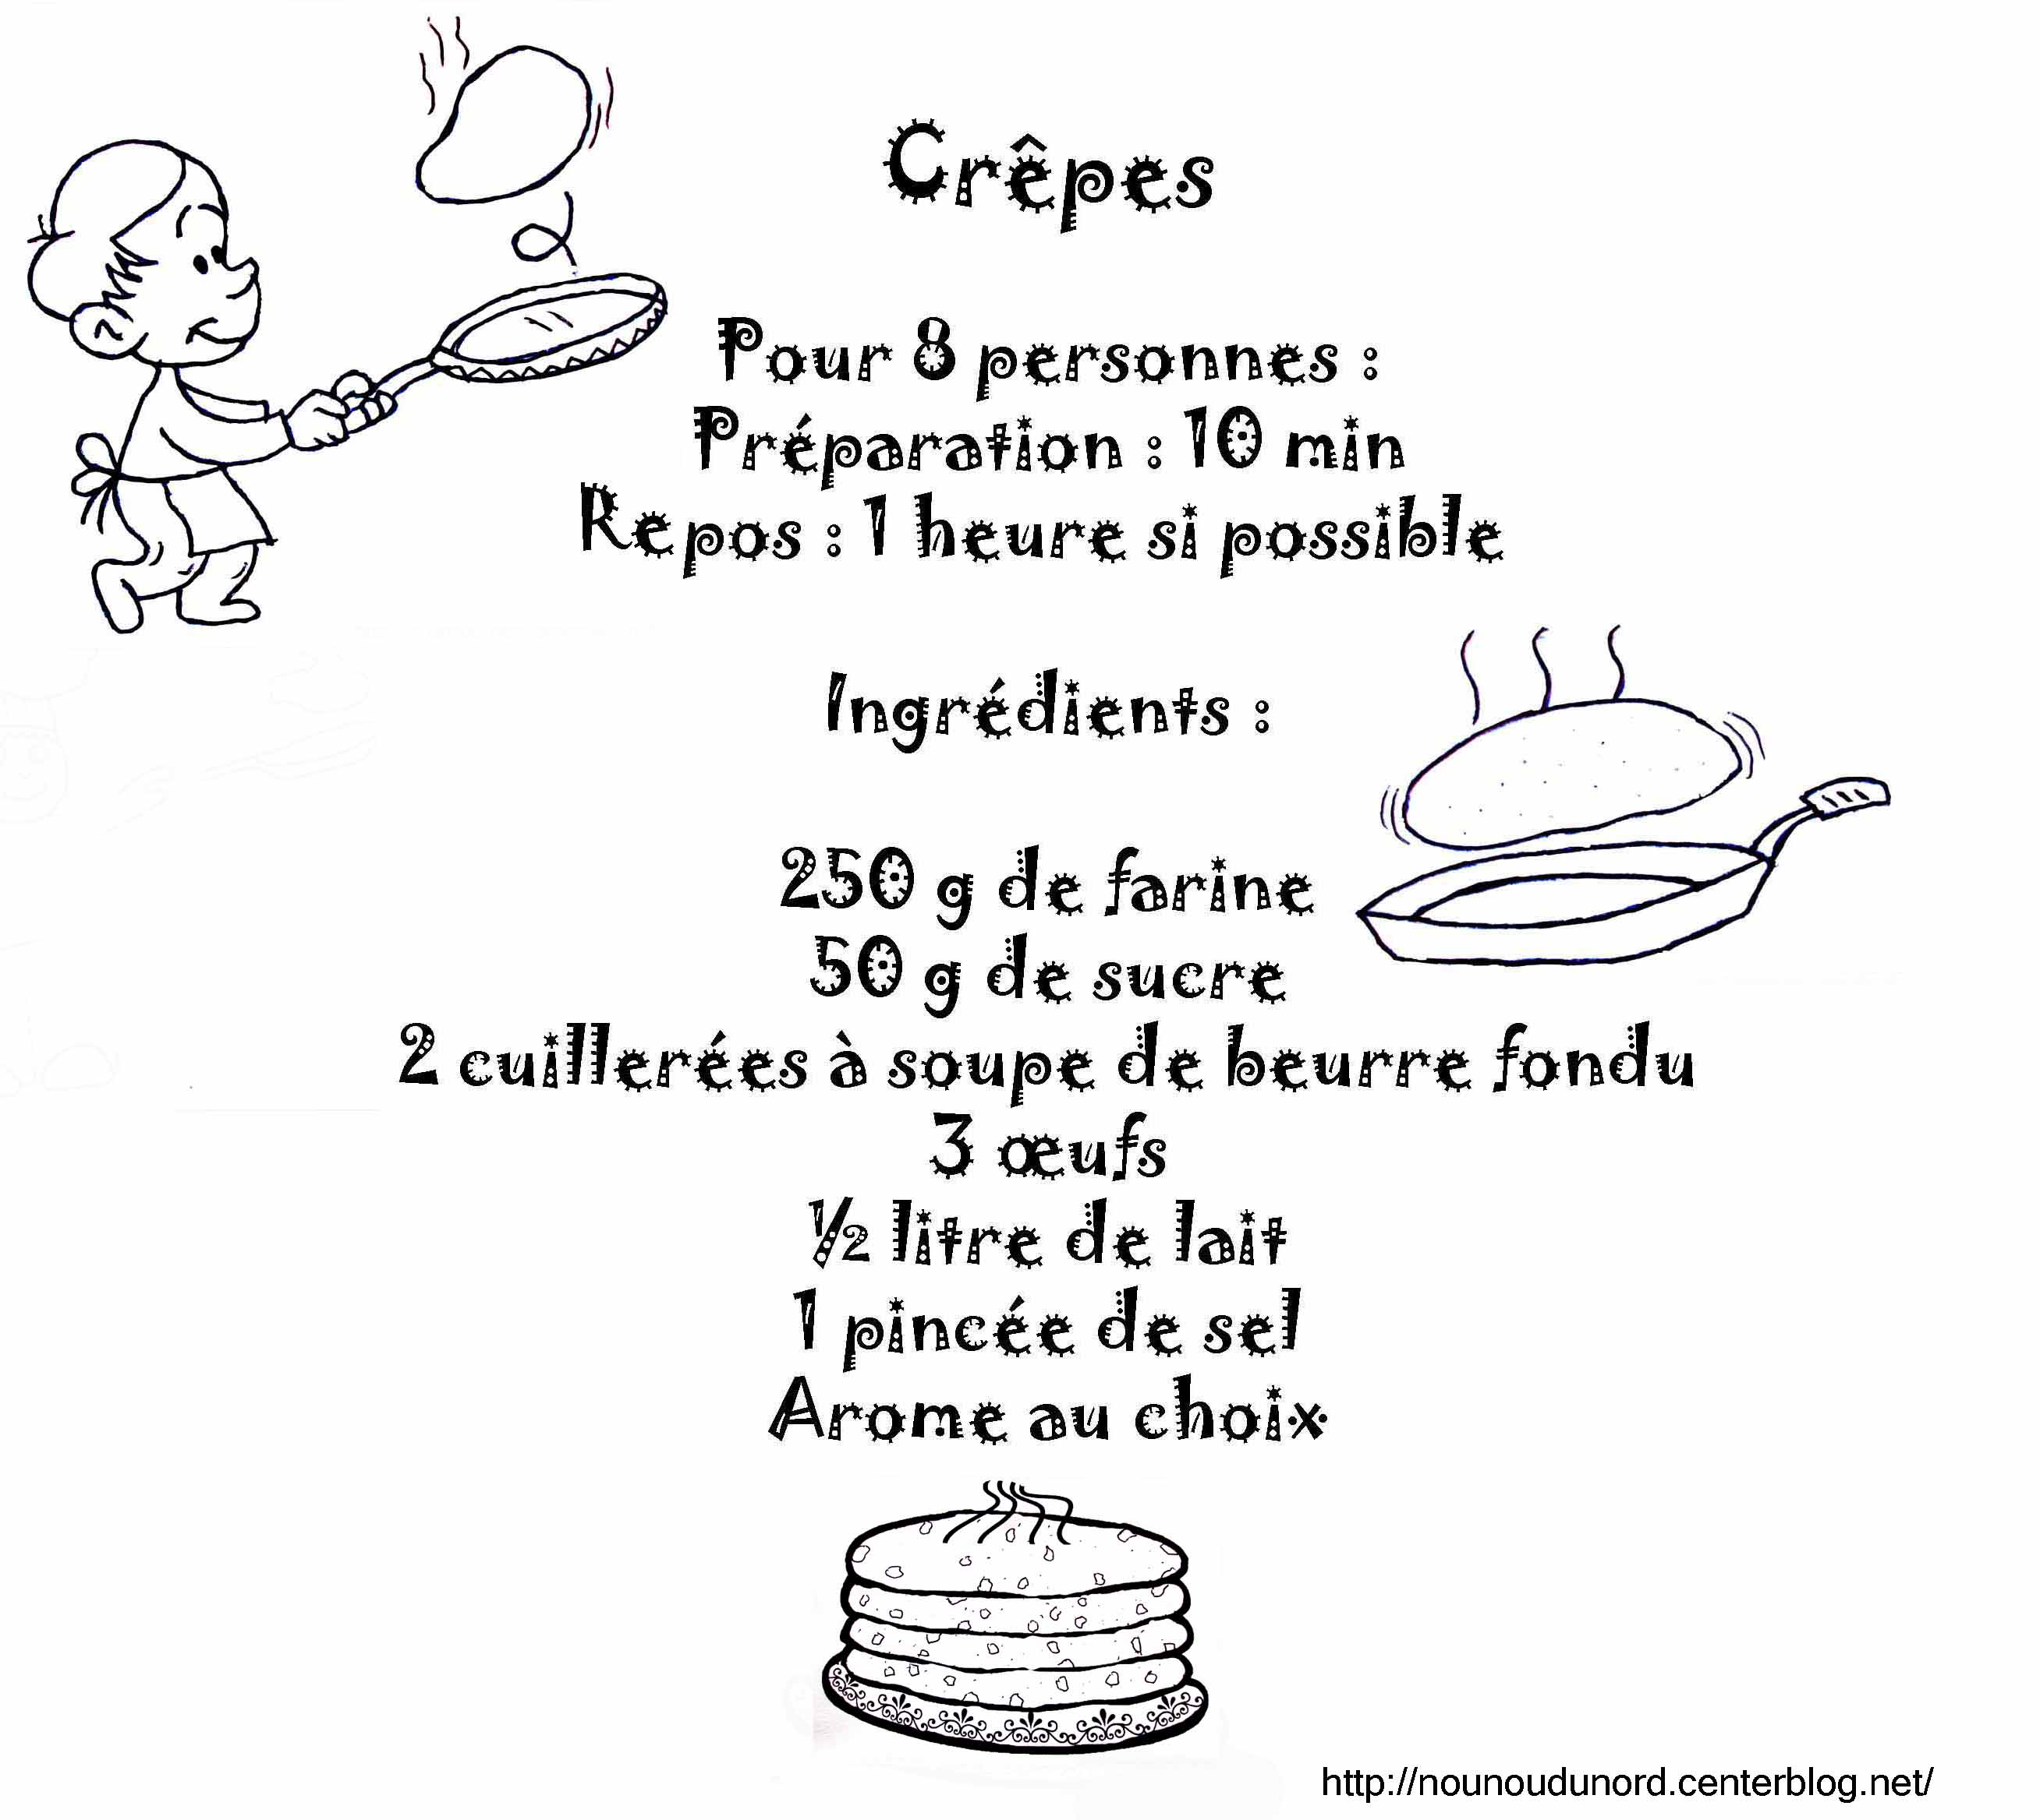Français 5 A1

Amis et compagnie 1 - Unité 3

By the end of Unité 3, you will be able to…
- ask if you like or not like a certain food/beverage
- identify foods and beverages
- identify meals
- ask for a certain food or beverage
- express your likes and dislikes for foods / beverages
- express / use different actions
- prepare and present skits (ex. in a restaurant)

To be able to do this, you will learn/review …
- vocabulary for foods, beverages
- how to ask questions (What do you like? What do you not like? Do you want…? )
- how to use “Il y a …” and “Il n’y a pas…”
- how to use partitive articles du, de la, de l’, des
- how to use the verb « vouloir »
- how to use –ER verbs in the present tense
- how to use the negative “ne/pas” with –ER verbs

You will also…
  - write/present New Year’s resolutions
  - compare/contrast foods from your country to French foods
  - learn about La Chandeleur, a French holiday
  - prepare “crêpes” for La Chandeleur
  - identify France’s major landforms, rivers, and cities

