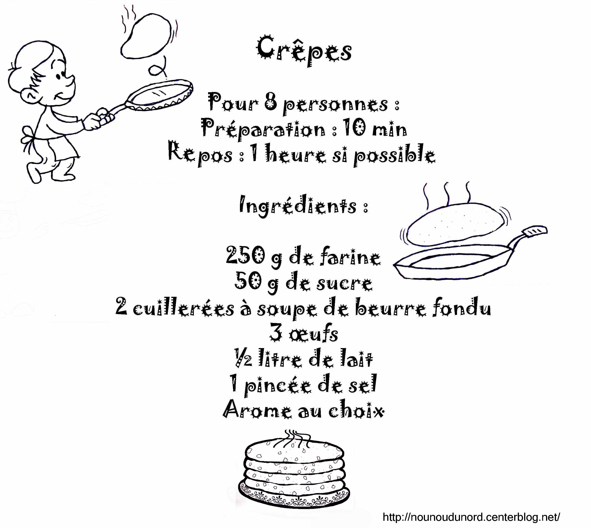

Français 5e : Amis et compagnie 1 - Unité 5

By the end of Unité 5, students will be able to…
- Communicate where you live
- Communicate where a particular building is located
- Ask for a direction
- Give directions to go somewhere
- Communicate what means of transport you use to get somewhere
- Communicate what you will be doing (eg. during the week-end)
- Use numbers from 0 – 100….
- Identify some famous sites (monuments/buildings) in Paris

To be able to do this, students will learn or review…
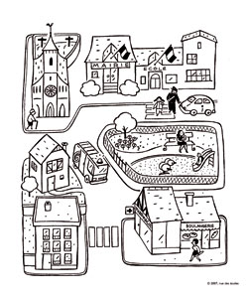
- vocabulary for buildings, means of transport (nouns)
- vocabulary for adjectives, adverbs and prepositions to use with nouns (ex. next to, between, in front of)
- how to use the pronoun “y”
- how to use prepositions “en” and “à” + mode of transport
- how to use the verbs « s’appeler » and « préférer » in the plural
- how to use the irregular verbs “aller, prendre, vouloir”
- how to use the imperative mood (giving commands)
- how to use the interrogative adverb “où” (where)
- how to use –ER verbs in the singular and plural
- how to use “tourner, traverser, aller” to give directions
- how to use the negative “ne/pas” with –ER verbs and irregular verbs
- how to use the verb “aller” (to go) to communicate what you will be doing
- Paris: names (vocabulary) of famous sites

