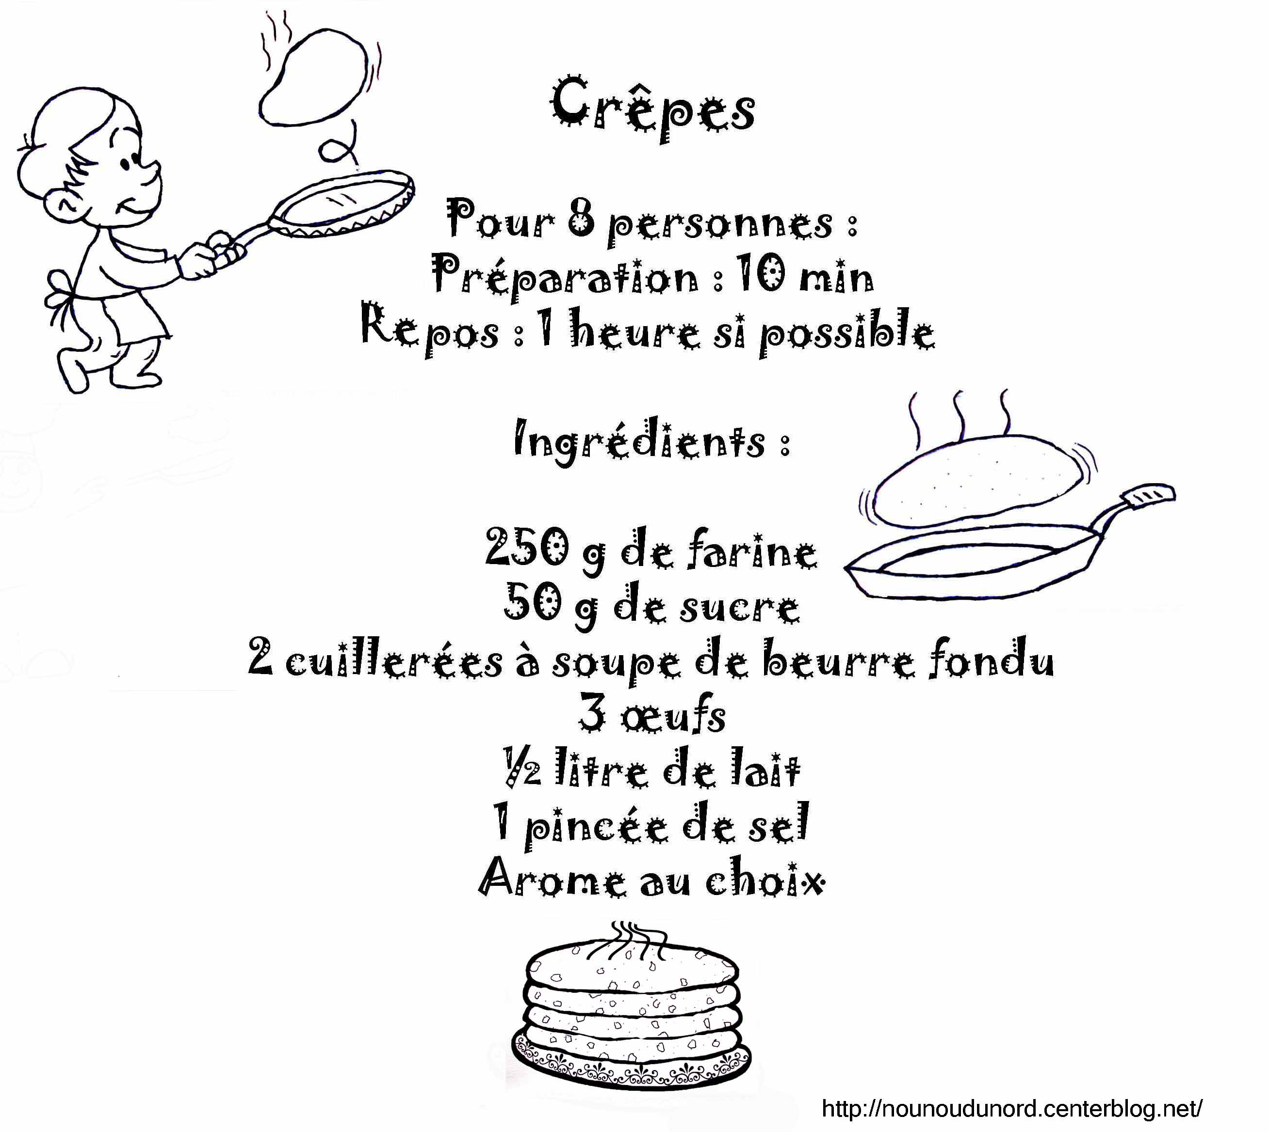Français 5/6 : Amis et compagnie 1 - Unité 4


Français 5 – Unité 4

By the end of Unité 4, you will be able to…
- ask if you like or not like to do a certain activity
- talk and write about your hobbies/after school activities
- talk and write about sports you do
- interview a classmate
- use numbers from 0 - 70
- express surprise

To be able to do this, you will learn or review…
- vocabulary for hobbies, sports
- how to ask questions (What do you like/not like to do? What do you like/not like to play?)
- how to use the pronoun “on”
- how to use prepositions à la, à l’, au, aux + a sport
- how to use du, de la, de l’, des + an activity
- how to use the verb « faire »
- how to use the verbs “aimer, adorer, détester, préférer” with an infinitive

You will also…
- learn about some symbols of France
- learn some facts about Paris
- write about your favourite activities
- interview a classmate


