Presentation Zen

Reynolds’ analogy of the Bento Box Presentation goes like this:

Picture Superiority Effect goes like this:

The Segmentation Principle of Multimedia Learning Theory goes like this:

The process of CREATING your design


- Planning (plan analogue (away from computer)

To make ideas sticky and achieve SUCCESS:

S
U
C
C
E
S

TOP TEN TIPS FOR SLIDE PRESENTATIONS
(according to Garr Reynolds)

- Keep it Simple--
- YOU are the star of the show, not the slides.
- Your slide should have lots of “negative” or “white space”--no clutter!

10.

FINALLY: Go to creativecommons.org

Creative Commons was created by:

For the purpose of:

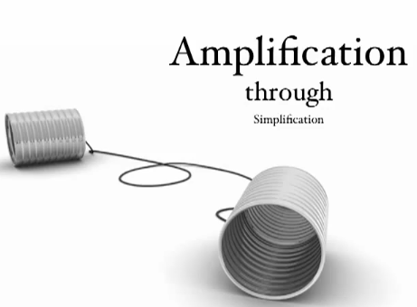
*YOU will use Creative Commons exclusively for copyright-free
images in your presentations. Either you create the images yourself
(with camera and/or digital processing, or you find a safe, legal image here.

