Exosolar Planets
By Bryce

Exosolar planets are planets that are not within our solar system.

Types of Planets
- Gas giant
- Water world
- Terrestrial

Formation

Planets form from the protoplanetary disk surrounding stars soon after they are created.

The disk is then only comprised of small particles like dust.

Gravity slowly pulls these particles together to make larger and larger objects which eventually become the planets.

What the planets are like after they are created is determined by the material in that certian area of the protoplanetary disk. The materials also determine what sze teh planet will be by the avalibility of materials.

Gas Giants

Examples: Jupiter and Saturn

Composition: Hydrogen (H), Helium (He), Helium compounds (water, methane)

Structure: Ice core, Metallic Hydrogen (caused by a great amount of pressure), Hydrogen and Helium gas envelope.

Water worlds

Examples: Uranus and Neptune

Composition: Hydrogen, Helium, Methane, Ammonia, Water, Rock

Structure: Ice and rock core, Water (liquid and ice), methane, and ammonia Mantle, Hydrogen, Helium and Methane outer gas envelope

Terrestrial

Examples: Earth, Venus and Mars

Composition: Iron and rock

Structure: core, mantle crust

Detection Methods

- Doppler Shift
- Transit method
- Coronagraphing

Doppler Shift

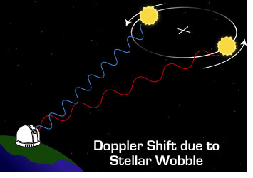
Because of the laws of physics a star with a planet will slightly alter its orbital path appearing as a wobble to observers outside the solar system.

This is the Doppler shift

Stars moving towards the observer go to the red end of spectrum
Stars moving away the observer go to the blue end of spectrum

Transit Method
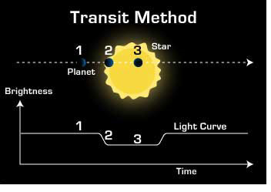
When planets move inbetween the star and observer

Temporary dip in stars brightness

Size of dip dtermines size of planet

The larger the planet the larger the effect

Coronagraphing
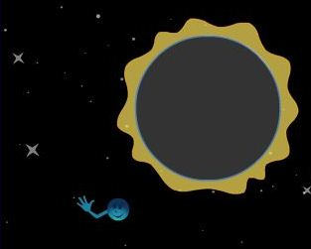
Physical mass to block out stars light.

Corona gives enoguh light to illuminate planet

The star does not make the area to bright for observation

Missions
Kepler -current
- Uses Transit Method
- Launcehed March 6 2009
- one meter diameter telescope
- moniter amound of sky covered by an arm held at arms length( two big dipper scoops)
- NASA funded

Hubble-current
- uses transit method
- Launched April 1990
- moniters amount of sky covered by a grain of sand
- NASA, ESA CSA funded
- Extreamly famous for pictures of nebule

James Webb-future
- infa red imaging
- can observe atmospheric compostition
- gathers data on planets
- planed launch 2013
- NASA, ESA, CSA developed
- 6.5 meter telescope

Naming
The name of the star -(letter in order of discover starting with b)
Bacause of order of dicover naming it can end up where e is closer ot the star than b

Examples

Gliese 581g
Located 20 light years
Anounced by NASA on september 29th 2010
Terrestrial planet that may suport water
11 years of observation was put into this effort
has three other plantets in the system

Fomalhaut b
Located 20 light years away in the souther fish
Gas giant
Anounced by NASA November 13th 2008
First exosolar planet to be photographed
one year on Fomalhaut b is equivilent to 872 earth years

Kepler 10b
560 light years away
Terrestrial and first that is most definatly rocky
only 40% larger than earth
orbit distance is 1/20 of Mercuries

Interesting Facts

- main reason for interest is to see if we are alone in the universe
- PSR 1257+12 B was the first exosolar planet ever discovered

PSR 1257+12 B orbits a pulsar
- Over 530 exosolar planets have been found
- Most planets are huge (many times the size of Jupiter)

